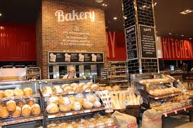

Final Project Stream One
Austrian Bakery Website
Christine Wilde | Full Stack Software Developer | 04.10.2017

Contents
1. Project Brief – Frontend Website 4
1.1 Website scope & target audience 4
2. Technical inclusions 5
3. The Prototype 6
4. Testing results & summary 8
4.1 Testing 8
4.2 Summary 16
5. The completed product – Austrian Bakery 18
6. Appendix 1 – BALSAMIQ prototype screens 23

Project Brief – Frontend Website
The goal of the stream one project is to build a frontend responsive Website. For my project I have chosen to design an Austrian bakery that offers a range of Austrian sweet and savory delicacies. My client is my work colleague Barbara Widholm whose dream it is to one day open an Austrian bakery shop near her home in London. Barbara is therefore my contact who has provided guidance on how her Business should look like on the Web and the products it should offer. The below bullet points list the items that are in scope for this Website and the target audience.
All files can be found on GitHub: https://github.com/ChristineMWilde/Stream_One_Project_GH.git

1.1 Website scope & target audience

Target customers and users:

- Austrian or other customers looking for Austrian products that are known to them and remind them of home.
- Customers with a sweet tooth but also savory to include a wider selection.
- Customers looking for a specific type of dessert especially those with the cinnamon spice.
- Customers looking for a café as well as a bakery.
- Customers looking to order bakery products online.
- Seasonal customers i.e. those looking for Christmas products which Austrian bakeries cater well for.

Scope according to brief:

- Menu bar for navigation (About Us, Bakery Products, Order Online, Delivery Availability).
- Audio and Images: Image gallery with Austrian music feature.
- Responsive bakery product order form.
- Product availability look-up feature.
- Footer (T&C, Social Media, Location: Contact & Address).

Technical inclusions
The list below highlights the technical tools used to accomplish the bakery Website from the initial prototype versions to the completed Website product.

Balsamiq
- Website prototypes

GitHub, GitBash, GitHub Pages
  - Hosting the software project files and version control
  - Creating repositories and branches for project files
  - Submitting final project

Sublime Editor
- Used as the text editor for writing the coded Website pages

(Semantic) HTML5
- Website HTML structure – DOM

CSS
  - General and advanced Website display (external style sheet)
  - Media queries to accommodate different screen sizes (external style sheet)

JavaScript & JQuery
- Responsive form, queries and navigation

Bootstrap
- Navigation bar and other nice features

Repl.it, Code Pen, Developer Tools Google
- Testing JavaScript, JQuery code and Website functionality

The Prototype

Location: https://github.com/ChristineMWilde/Stream_One_Project_GH \ Prototype \

Based on the target audience mentioned in 1.1 the Website needs to cater for many people bearing in mind that the customers are looking for a bakery and/or ordering online.
The following observations were made before building the prototype. This led to the design and usability table shown in table 1. The BALSAMIQ prototype designs are found in Appendix 1.

- Customers looking for a bakery should be informed of the Cinnamon Magic bakery address.
- Customers looking to order bakery products online should be provided with an online booking form.
- Since customers include those who potentially speak German the site should have a translation facility especially for the products.
- Those looking to book online need to know if the product is available and therefore the website should feed back to the customer if the product is unavailable.
- The “look and feel” of the website will also give an expectation on what the actual bakery store would be like so the design should come across as ‘handsome’ and eye grabbing especially appealing to the sweet tooth.
- The products should be authentic Austrian with cinnamon spice and include some savory and seasonal ones too.

Table 1

Design & usability of the Website

FEATURE | GOAL
Background | Should serve to promote the products and be eye catching. This should include chocolate, cakes and coffee (for those customers looking for a beverage too at one of the stores). The images should be elegant so customers get a good feel of the bakery store.
Color | The color decided upon is medium brown to reddish which matches chocolate and coffee for a typical bakery/café feel.
Navigation bar | Simple and easy to use highlighting the Cinnamon Magic brand name
Translation facility on product page | Easy to use and translate the products description page
Store location facility | There are many customers to cater for so the location store look-up should be UK wide.
About us page | Information on the company including the store opening times.
Products | As noted Cinnamon Magic is a bakery/café but is also based on Austrian products so the product selection should include 3 categories: Bakery products, Savory and Seasonal. The categories will be shown on a Bootstrap carousel.
Online form | An easy to use online form with validations
Payment facility | The booking form to lead the customer to the payment site once selections have been made.

Testing results & summary
Location: https://github.com/ChristineMWilde/Stream_One_Project_GH \ tests \

4.1 Testing
This section firstly outlines the testing that took place using mostly JavaScript and some JQuery. The aim was to make the Website standout and be responsive. To make the readability of the testing results clear the tests are sectioned into each individual Website page.
- General: Website page loading test:
Error: Cannot read property….
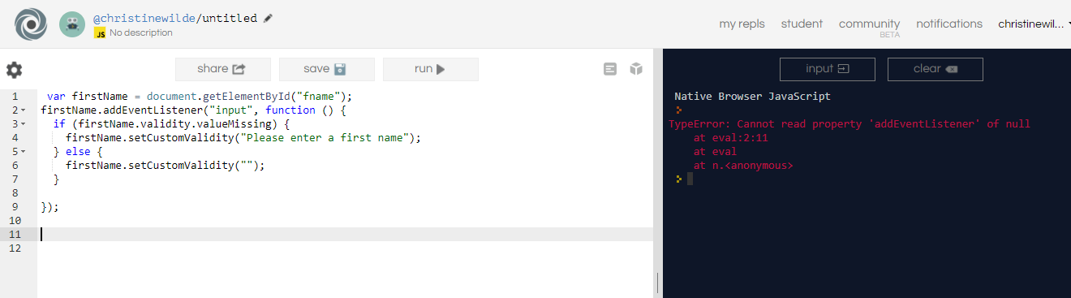
The JavaScript to find a HTML element’s ID was not loading correctly.
The following Event Listener property was added and tested in Repl.it to solve this issue. This function now sits at the top of the JavaScript file prior to any code.
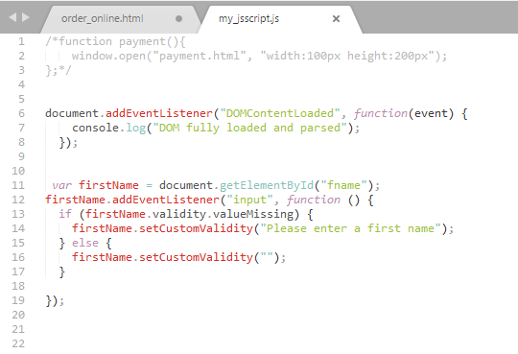
This can be viewed further in developer tools on the browser
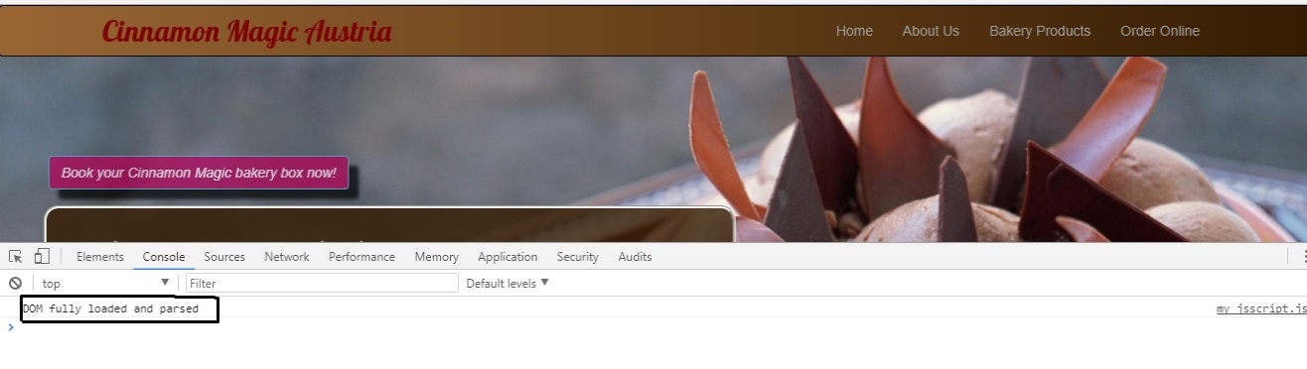
- Home page – look-up a store test:
The following HTML was written for users to select a store:
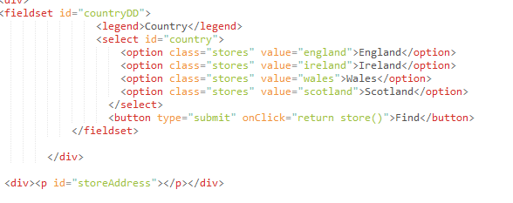
The below JavaScript was tested:
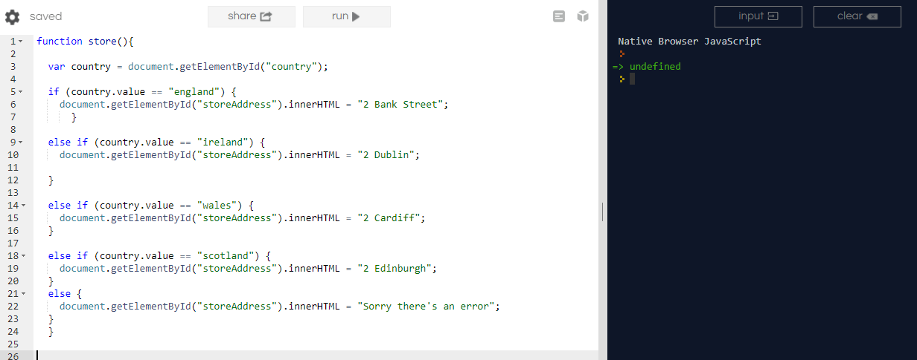
This worked however was re-worked into a dictionary:
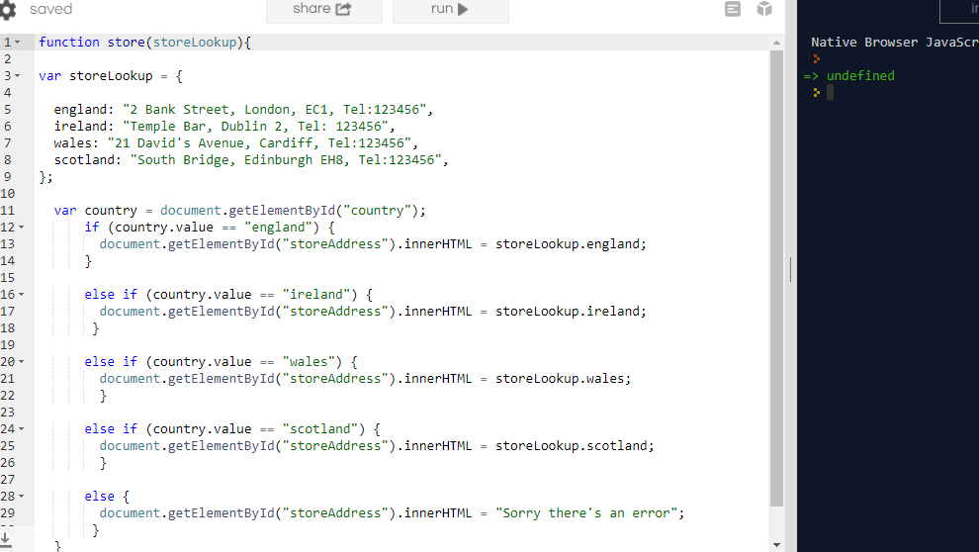
- Home page – Animated button JQuery test:
Code pen was used to test the animated banner to ensure the code was well structed especially on CSS and JQuery. The JQuery code was entered so that customers can click on the animate banner which draws their attention and once clicked directs them to the booking online page. The Bootstrap button class btn (btn-info) was used for the button.
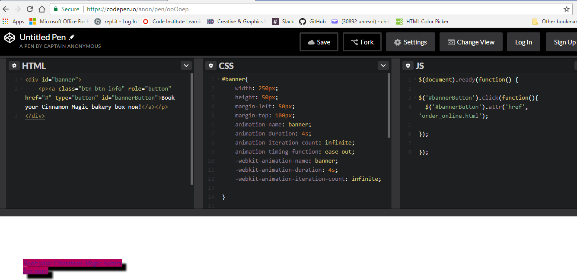
- Bakery Products page – production description translation test:
At first JQuery was used to select each button i.e. German \ English and translate to the relevant language per below:
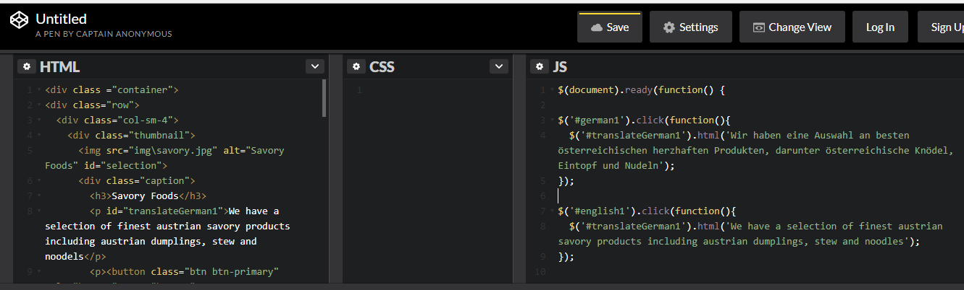
However similar to the store lookup from the Home page this was altered and JavaScript used instead to create a dictionary:

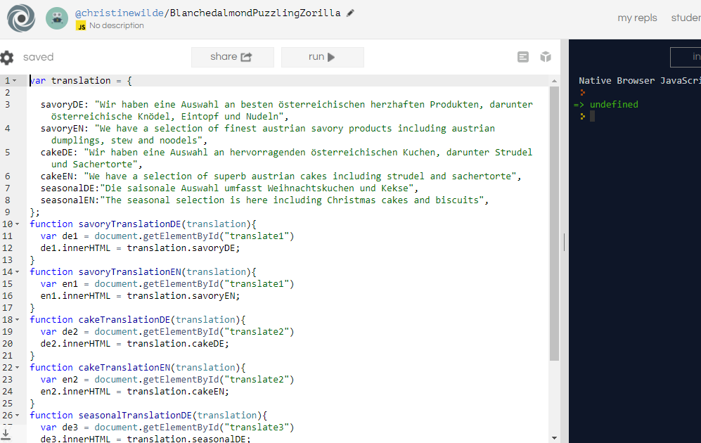
- Order Online page – booking form tests
  - Validate form user first name and surname test:
I approached the user details e.g. name, address using the form name and the element’s ID per below.
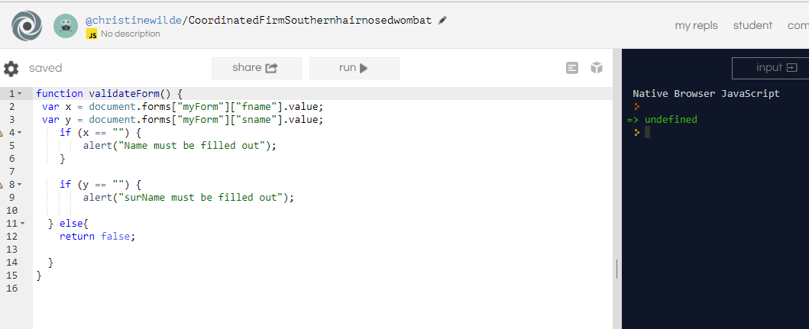
  - Validate form email test:
I used the code per below for the email validation which validates that the email should contain the ampersand character @ symbol and . (dot) including validating that there should be characters before and after the @:
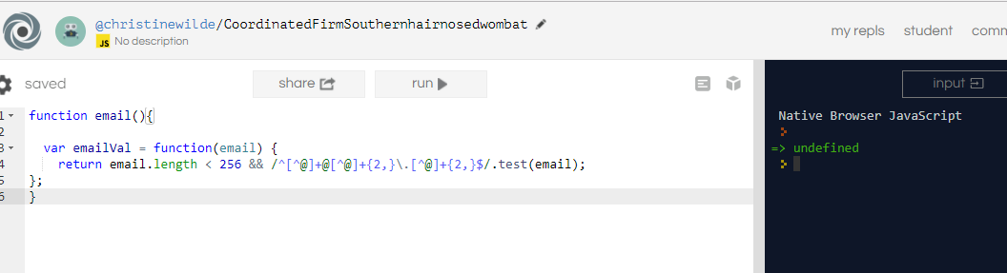
  - Validate form password test:
The password is based on a validation that the length should not be under 6 or over 10 characters:
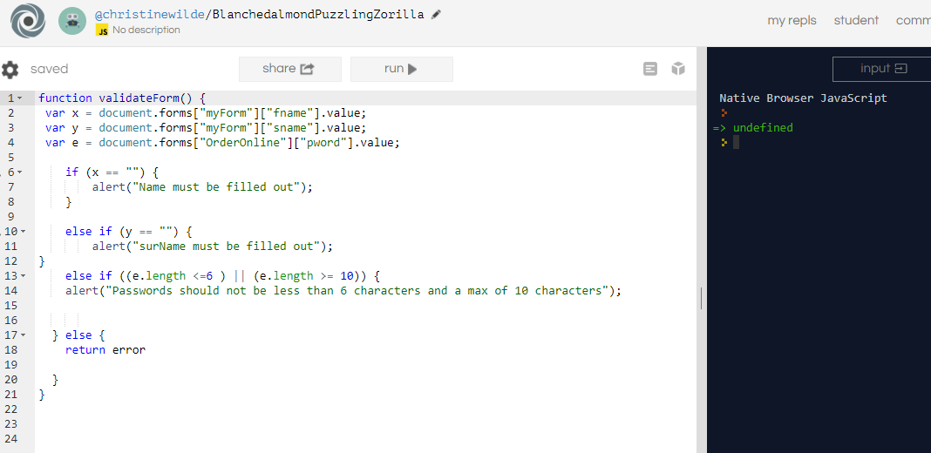

  - Validate form open payment page once form is correctly filled out test
This was entered in the validateForm function and tested first in Repl.it then via sublime files and browser to ensure users would be re-directed to the payment page:
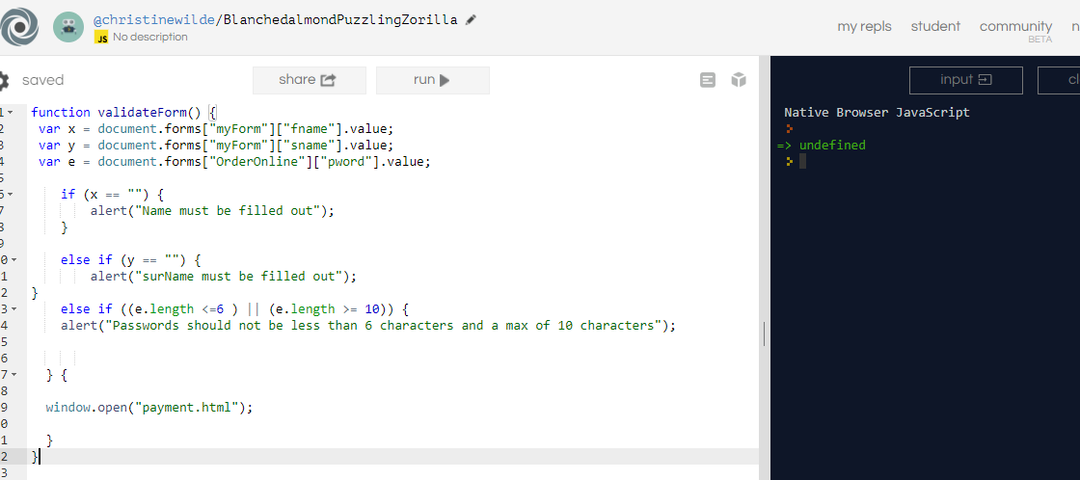
  - Complete form validation test
The completed code was entered in Repl.it altogether then tested as a user on the browser to ensure all validations were working:
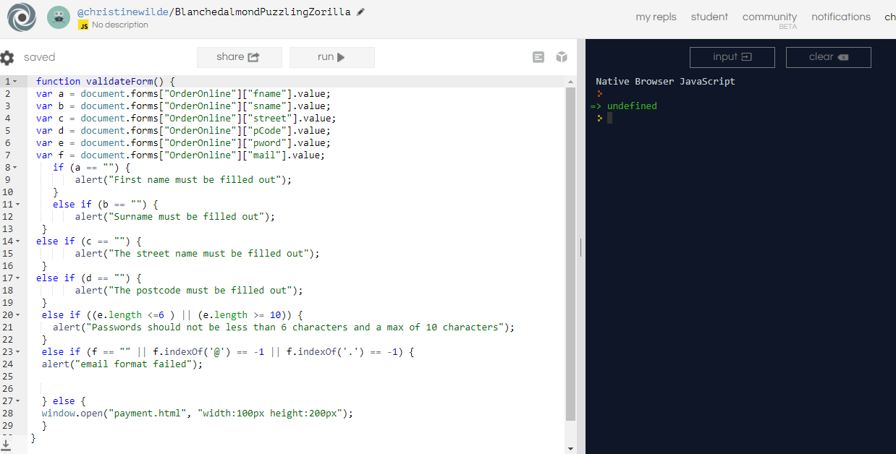

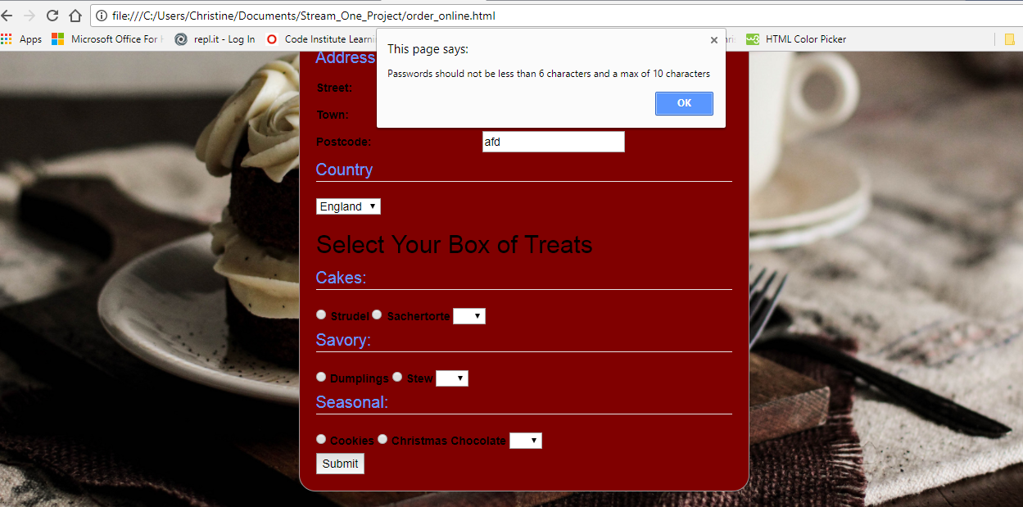
- Order Online page – Product availability validation test
Each product category was given a function to feedback to the users if the product quantity is not available:
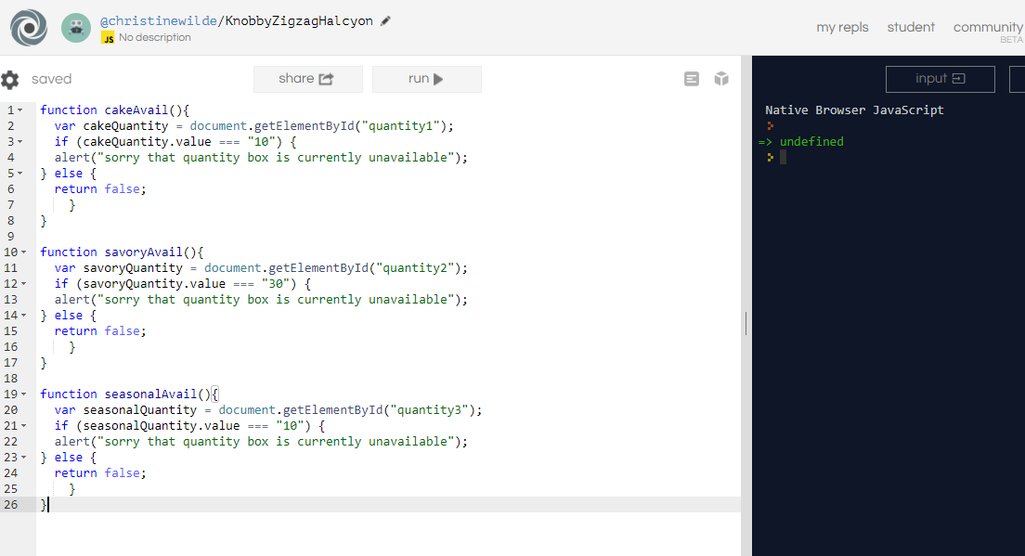
- Booking Payment form – Card validation test
Code pen was used since it also displayed the payment boxes on the same screen which is a nice feature when testing. The validation aims to restrict the card number length and ensure that ‘null’ is not entered:
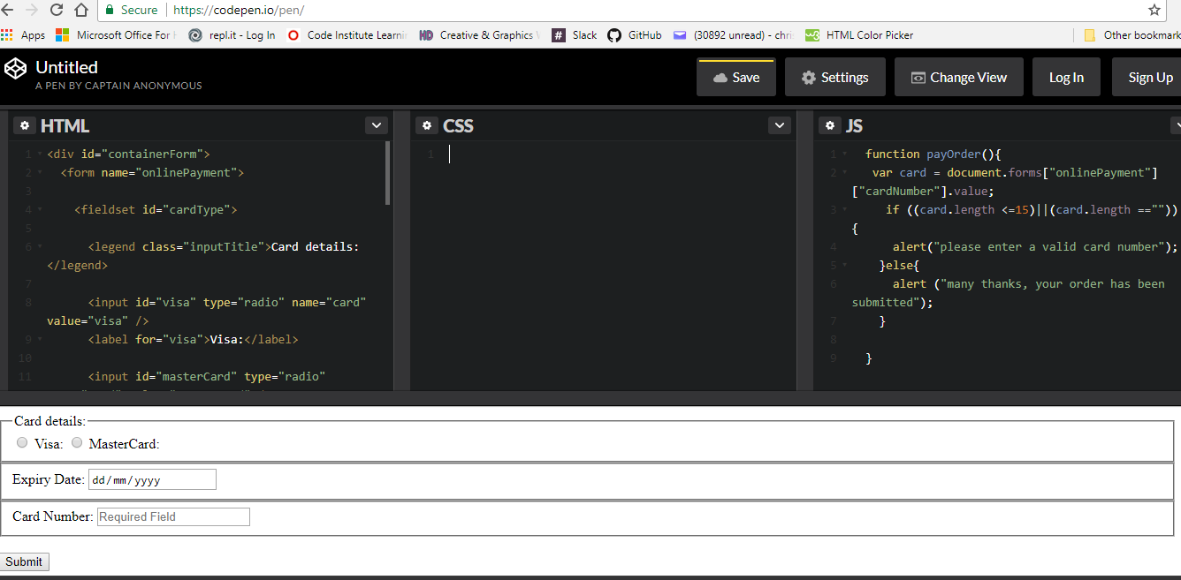

4.2 Summary
After the development and coding of Cinnamon Magic the usability and design table was updated to highlight the observations and the alterations done. This was necessary as after testing, designing and coding some features inspired via the prototype phase required updating. Please see table 2 below.
Table 2
Design & usability of Cinnamon Magic post testing & development

FEATURE | RESULT
Background | The overall background matched closely to the prototype although the Bakery Products page changed. The design from the prototype was found to be too distracting so a one picture covering the page suited the page much better. Added to this the designed lacked a bit of the “Austrian feeling” which was aimed for so a snowy Austrian forest picture was chosen instead.
Color | The color matched to the prototype’s aim and Google font ‘Lobster’ was chosen.
Navigation bar | Bootstrap navbar was chosen ensuring this could accommodate small devices too.
Translation facility on product page | JQuery was initially used for the English to German translation but that was then removed to use a JavaScript defined dictionary instead so wording in future can be easily updated.
Store location facility | Instead of a separate ‘store & location page’ it was felt that customers would wish to know the locations straight away so the location including the store opening times were instead placed on the Home page.
About us page | This include Bootstrap Jumbotron code to highlight the information. The store opening times was still kept on this page too falling under the bakery’s information.
Products | The design matched the prototype and Bootstrap thumbnails were used. A Mozart audio file was added to complete the project brief and also provide further Austrian aesthetics to the site.
Online form | An easy to use online form was designed. The background was updated to a one picture cover similar to the results under ‘background’ feature above.
Payment facility | Instead of an envisaged pop-up payment feature, JavaScript function was use to direct the user to a new payment page which is more typical of Website payment features. Therefore, a new page was designed. Not much emphasis was given to the background on this page since the focus should be on a secure payment facility.

The completed product – Austrian Bakery

Home page
Includes Bootstrap navbar with brand name, animated banner directing users to the Order Online page, a store look-up feature and the store opening times using Bootstrap modal.
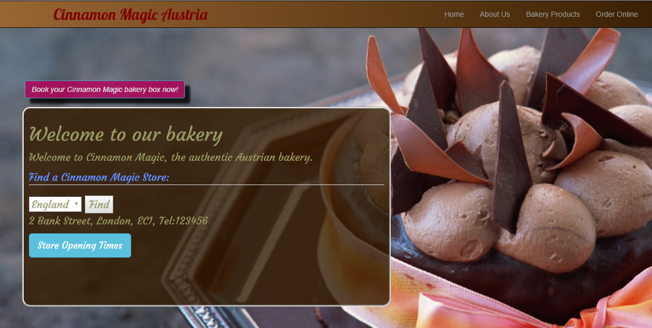

About Us page
Includes Bootstrap navbar with brand name, Bootstrap jumbotron announcement with bakery description and the store opening times using Bootstrap modal

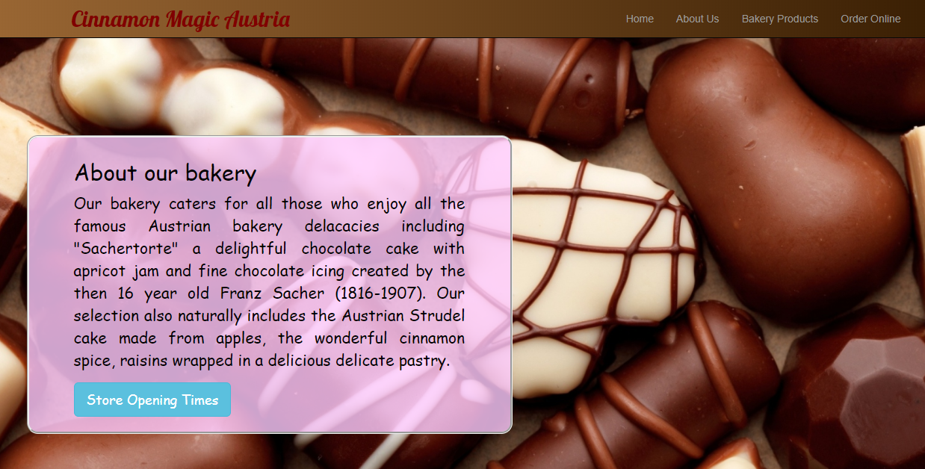

Bakery Products page
Includes Bootstrap navbar with brand name, Bootstrap carousel, audio file playing Mozart, and Bootstrap thumbnails for each product category. An interactive feature is provided updating the product descriptions to either the German or English language.
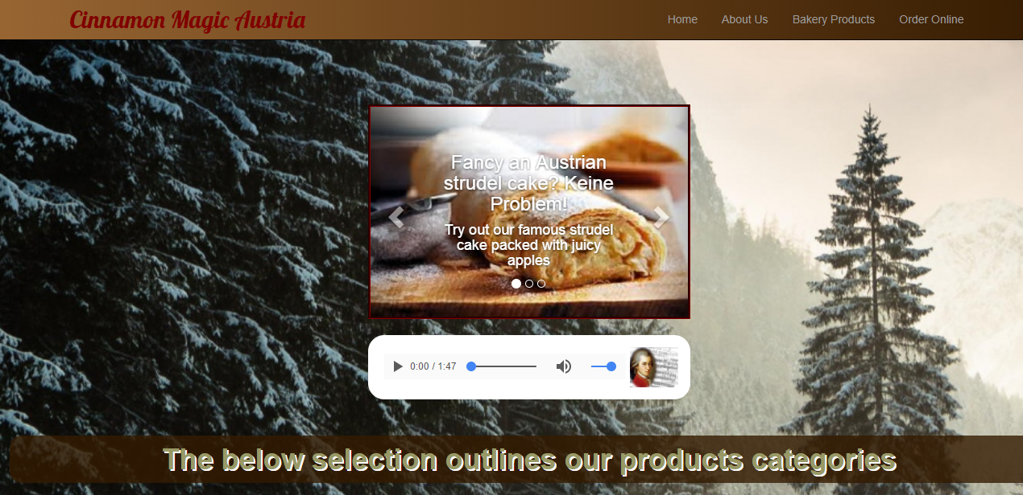
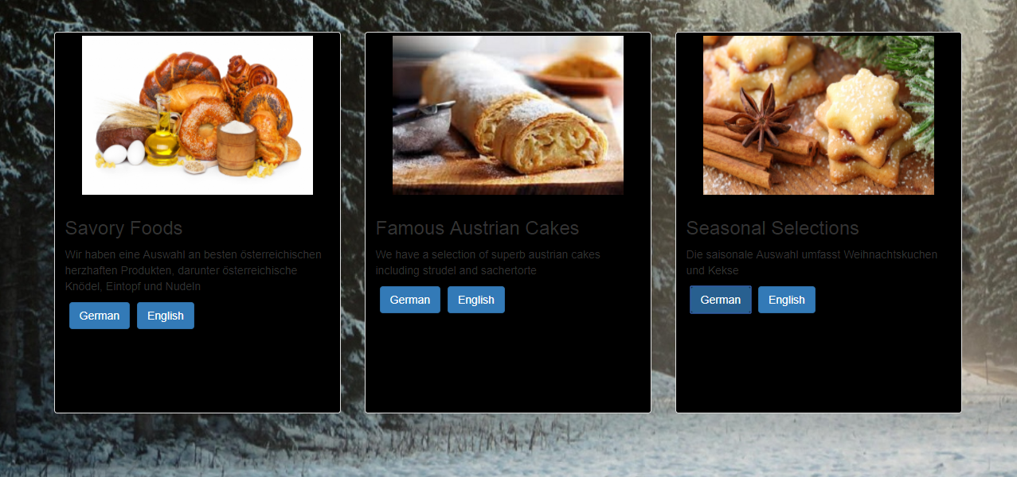

Order Online page
Includes Bootstrap navbar with brand name, booking form with validations on input fields including password, email and product availability

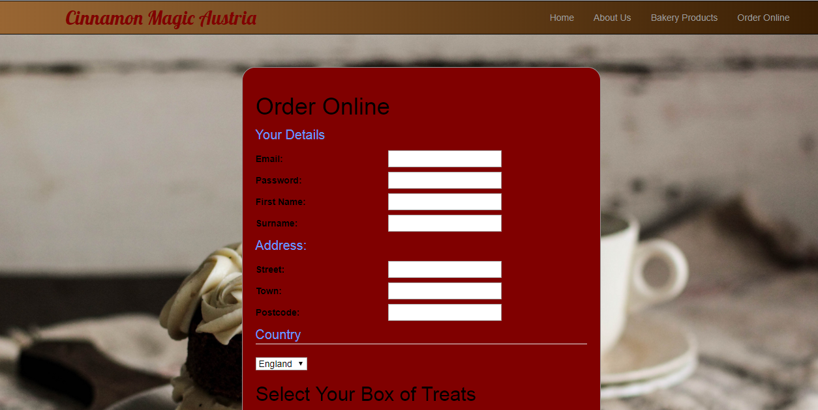

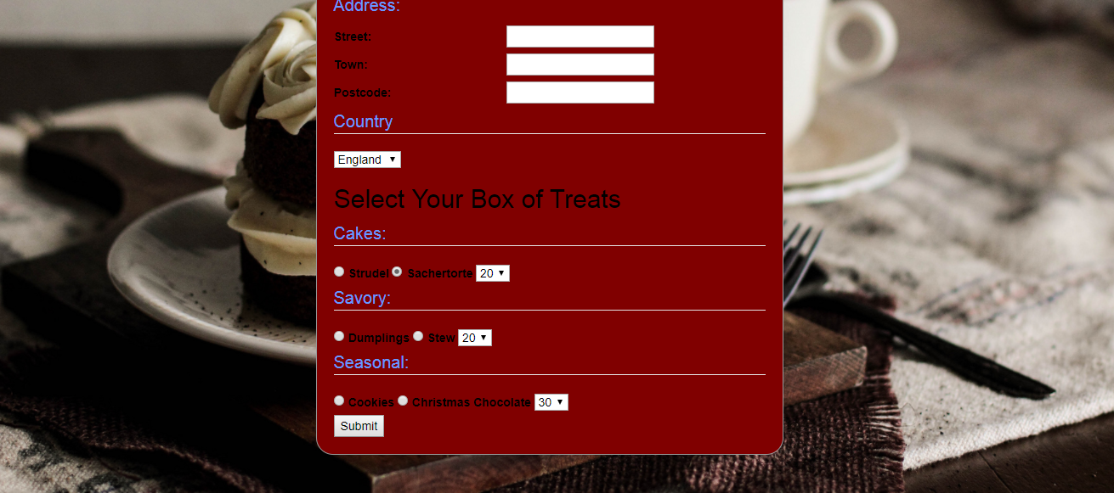

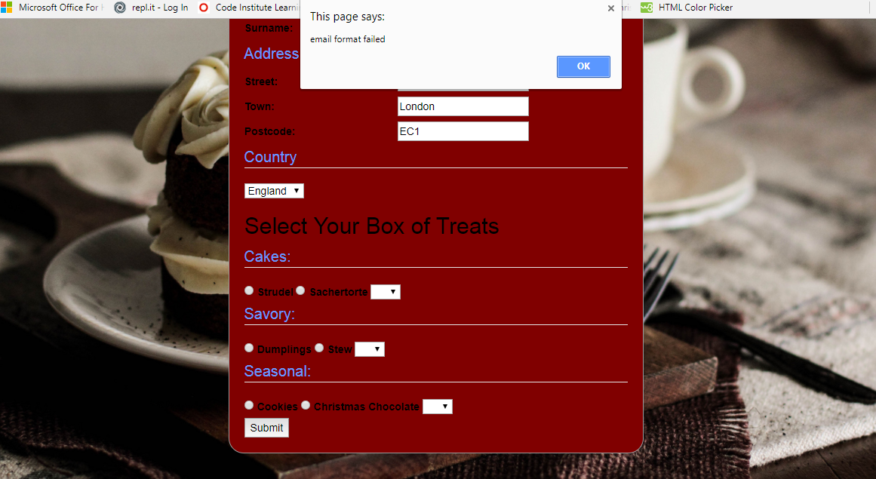

Order Online Payment page
Includes Bootstrap navbar with brand name, payment form with card validation. The card expiry date is provided by the HTML input type ‘date’.
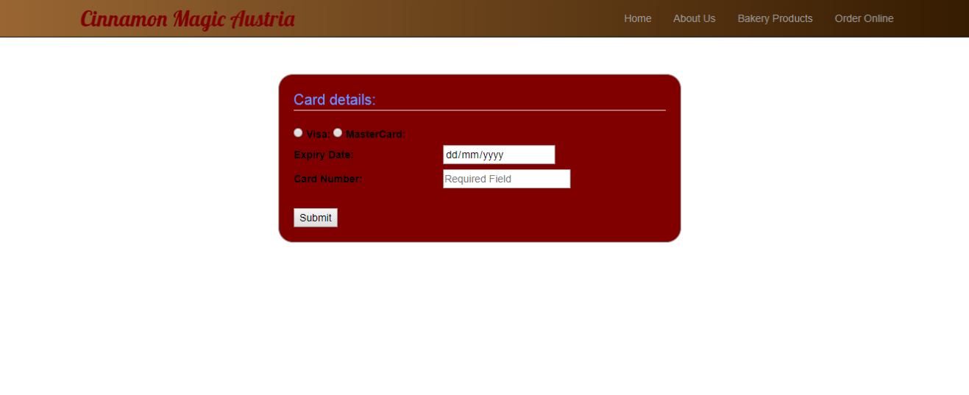

Appendix 1 – BALSAMIQ prototype screens
Home page
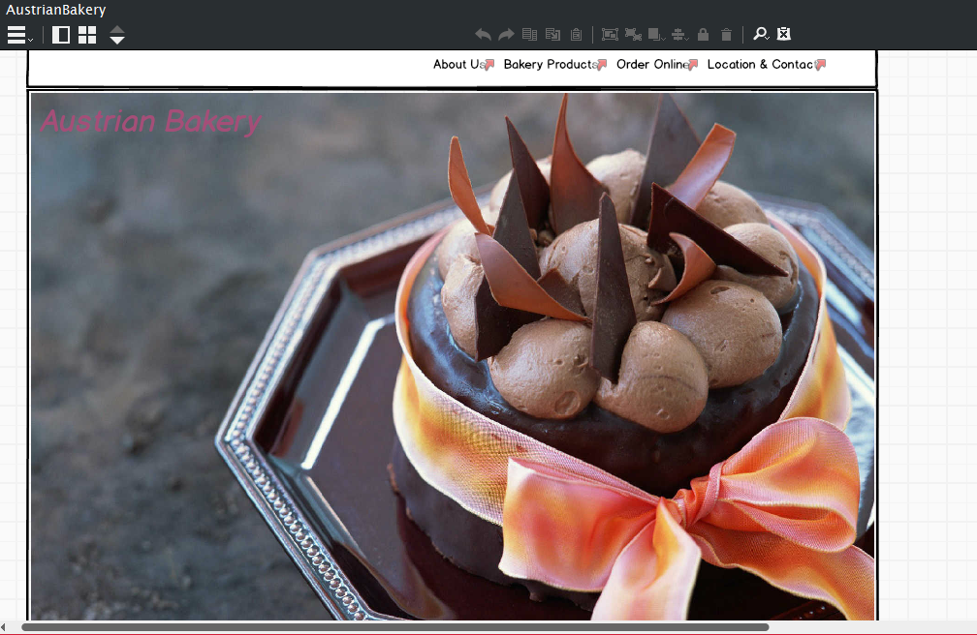

About Us page
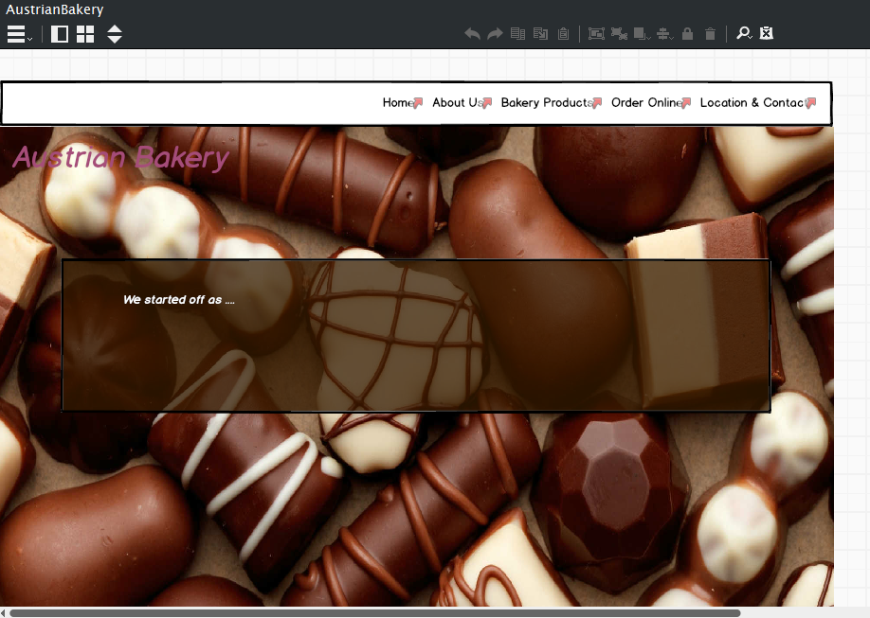

Bakery Products page

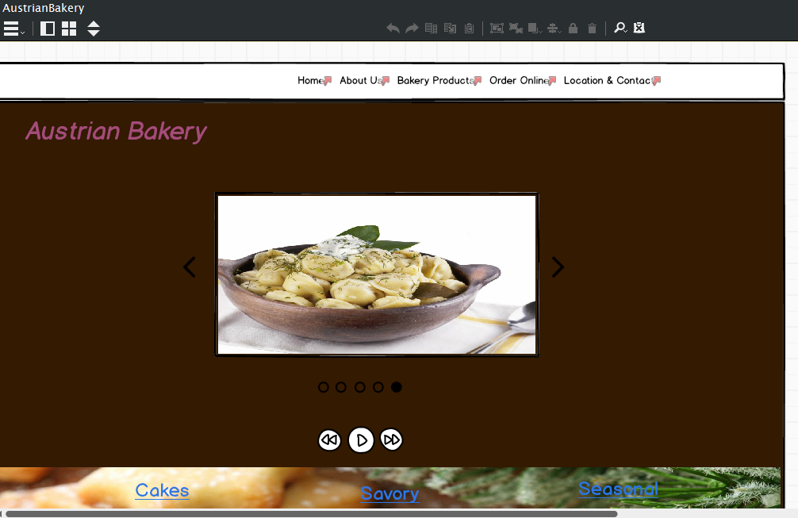

Order Online page
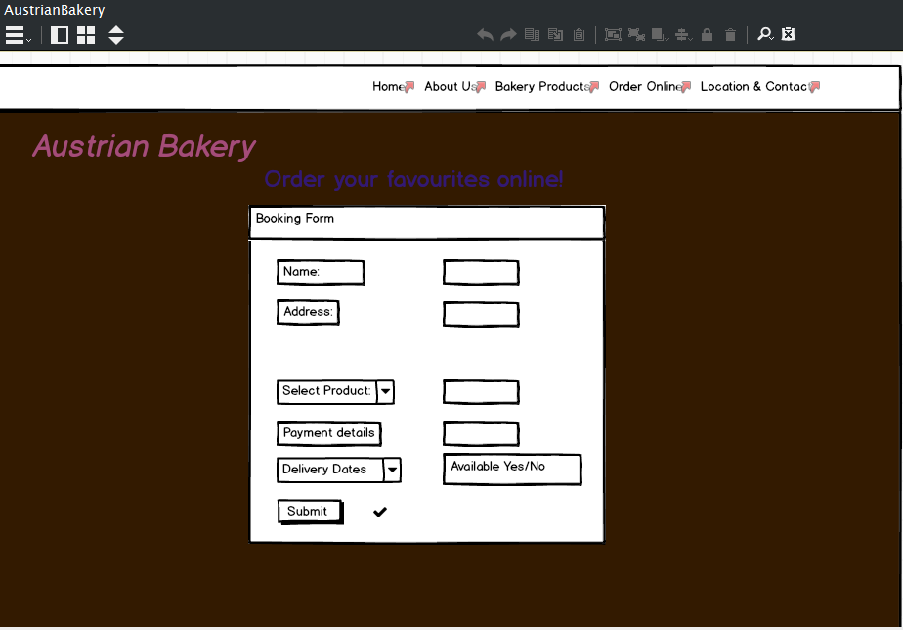

Location and Contact page


